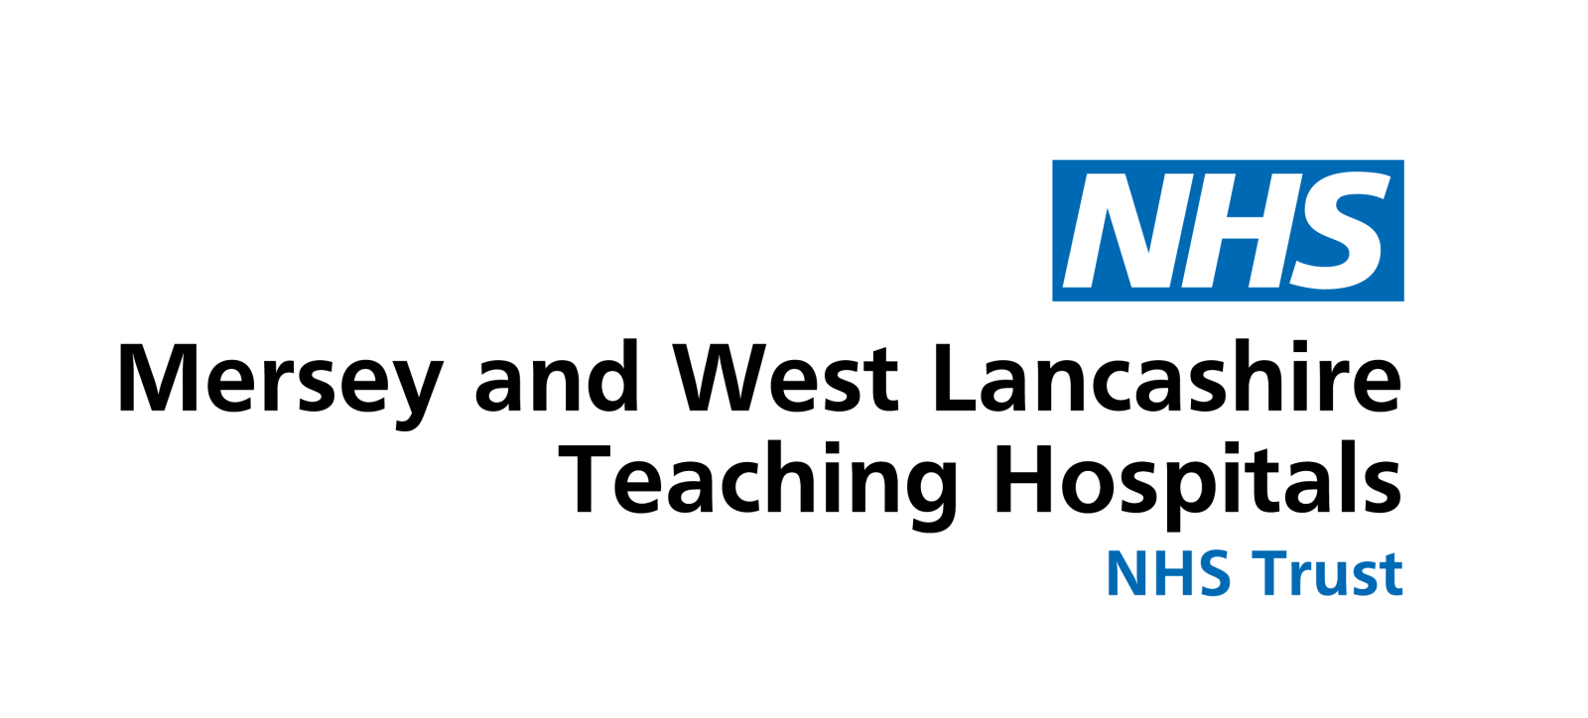

Ref. No:
Date:
Subject:
1782
27/05/2025
Expenditure on confectionery and sugar-sweetened beverages

REQUEST

For the years 2023/2024 and 2024/2025:

1. How much did your authority spend on confectionery (including chocolate, crisps, sweets, cakes, etc) and sugar-sweetened beverages (SSBs) for resale to patients, staff, and the public?

2. What was the approximate percentage mark up for the items referred to in question 1?

3. How much profit did your authority make from the sale of items referred to in question 1?

RESPONSE

St Helens and Knowsley Teaching Hospitals NHS Trust and Southport and Ormskirk Hospital NHS Trust became a single legal entity known as Mersey and West Lancashire Teaching Hospitals NHS Trust on 1st July 2023, as such parts of the response may be provided in two sections relating to the hospital sites of each of the legacy organisations.

Whiston and St Helens sites:

- How much did your authority spend on confectionery (including chocolate, crisps, sweets, cakes, etc) and sugar-sweetened beverages (SSBs) for resale to patients, staff, and the public?

All outlets at Whiston and St Helens Hospitals selling confectionary to patients, staff and members of the public are independently run by the Trusts PFI Partners, Medirest and Gentian who operate within the building e.g. COSTA, WH Smith, Greggs.

As such the Trust does not purchase these items directly.

- What was the approximate percentage mark up for the items referred to in question 1?

Not applicable.

- How much profit did your authority make from the sale of items referred to in question 1?

Not applicable.

Southport & Ormskirk sites:

- How much did your authority spend on confectionery (including chocolate, crisps, sweets, cakes, etc) and sugar-sweetened beverages (SSBs) for resale to patients, staff, and the public?

A retail facility managed by WRVS operates on both Southport and Ormskirk Hospitals, the Trust does not purchase these items directly.

Items procured for sale through the hospitals restaurants and coffee shop are as follows: -

2023 /2024: Total = £121,543.03

2024 / 2025: Total: £106,382.55

- What was the approximate percentage mark up for the items referred to in question 1?

The confectionary that is supplied from the Trust’s own in-house services are sold at a price that offsets the cost of the goods and the associated staffing costs and overheads, a generic mark-up percentage is not available.

- How much profit did your authority make from the sale of items referred to in question 1?

N/A profit is not made from this service. See question 2 response.

